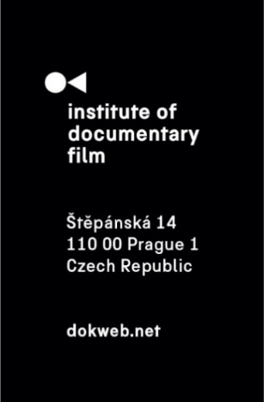
Press Release, Prague, 22. 5. 2025

ERIAC supports filmmaker Sami Mustafa at Ex Oriente Documentary Workshop

The Institute of Documentary Film (IDF) is pleased to announce that filmmaker Sami Mustafa has been selected as the recipient of a special scholarship to participate in the Ex Oriente Documentary Workshop 2025, made possible through a new partnership with the European Roma Institute for Arts and Culture (ERIAC).
This partnership reflects a shared commitment to supporting emerging Roma filmmakers from Central and Eastern Europe, offering them access to professional development, international mentorship, and a collaborative creative environment. Through this initiative, ERIAC covers the participation costs for one selected Roma filmmaker, helping them take their documentary projects to the next level.

“Roma in film shatter stereotypes, offering raw, poetic visions of resilience, beauty, and defiance. True inclusion means Roma behind the camera too, shaping narratives. The future of film is incomplete without Roma voices at its heart,” says Timea Junghaus, Executive Director of ERIAC.

The 2025 ERIAC scholarship has been awarded to Sami Mustafa for his upcoming project Symphony of Seasons (dir. Sami Mustafa, prod. Faton Mustafa – Third Eyes Pictures, Sami Mustafa – Romawood, co-prod. Laurent Billard – Les Films Du Tourbillon, XK, FR).

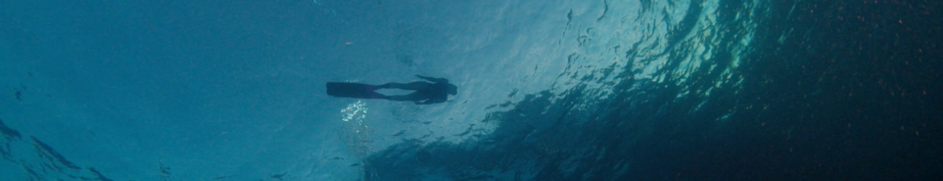

About the project:
Symphony of Seasons follows Sami Mustafa, one of the few Roma filmmakers in the world in his search to re-evaluate his Roma identity that leads him back to his Kosovo roots, where generations of oppression and resilience shape the legacy he carries. His mother, who becomes a guide and the seasons as adversary we witness stories of displacement, struggle, and survival of one family as the children of wars.
As the film unfold in four movements of seasons and four stage of life, each chapter infused with life's elemental rhythms—birth, childhood, adulthood, and elderhood is narrating a transformative journey while investigating a society of perpetuating stereotypes towards the Roma people and the rise of extreme-right ideologies.

The film mediates intergenerational trauma, belonging and unspoken ties that bind us to our origins. Can we find a way to reconcile with our past without being bound by it?

About Sami Mustafa
Sami Mustafa, a French-Kosovar Roma, is an independent documentary filmmaker, producer, and writer. He is the founder of Romawood and the Rolling Film Festival, where he serves as artistic director. He is currently an honorary member of the European Roma Institute for Arts and Culture (ERIAC) and a member European Film Academy. His latest film Trapped by Law won best film Award at the New York Film Festival, Discovery Young Talent Award at Cottbus Film Festival numerous nominations. Since 2011 he moved to live in France and hold double nationalities.

Ex Oriente Film 2025 is made possible with the support of Creative Europe MEDIA, the Czech Audiovisual Fund, and the Ministry of Culture of the Czech Republic.

About the Institute of Documentary Film
Since 2001, the Institute of Documentary Film (IDF) has been supporting Eastern and Central European original documentary films in all stages of production. It assists emerging and experienced directors with the development of their films, and producers with the financing, distribution and promotion of their films, as well as with orientation on the international market. All this with the help of the vast experiences of renowned international experts. Films supported by IDF activities regularly win awards at leading film festivals. For the public, the IDF organises lectures and screenings of the most interesting documentaries not only in cinemas but also in various alternative spaces.

dokweb.net

Media contact:
Anna Jurková | PR IDF | tel.: +420 605 136 254 | e-mail: jurkova@dokweb.net

