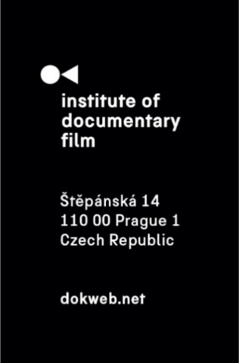
Press Release, Prague, 2. 5. 2025

Short Pitch Program 2025: Selection revealed

The Institute of Documentary Film, in partnership with the Millennium Docs Against Gravity Film Festival, is proud to announce the five short documentary projects selected for this year’s Short Pitch Program, taking place on May 10, 2025, in Warsaw.
Designed for emerging filmmakers from Central and Eastern Europe, the Short Pitch Program provides a unique platform for directors of short documentaries to present their work-in-progress to a curated audience of sales agents, distributors, festival programmers, and broadcasters. Each selected team will deliver an 8-minute pitch followed by a Q&A session, offering direct access to key industry players.

Prior to the public event, participants will undergo expert-led consultations to refine their presentations and update their pitch decks, ensuring they are tailored for an audience of decision-makers. Following the pitch, one-on-one meetings will be held with select industry representatives.

Here are the five projects selected for this year’s edition:

Amma, Do Giraffes Cry? (dir. Kartikeya Saxena, Czech Republic, 2025, 25')
In this magical-realist documentary, a filmmaker’s fantastical worldview collides with his zoologist mother’s rigidly rational approach to the natural world. The filmmaker’s encounters with captive animals at the Prague Zoo take the mother-son duo back in time. As memories of wild tigers and pet rabbits resurface, the zoologist is forced to confront a long-held belief.

Eyelashes and Sand Crystals (dir. Daryna Mamaisur, Ukraine, 2025, 25’)
The Herbarium of Kherson State University, one of the largest collections of lichens, vascular, and bryophyte plants from southern Ukraine and Crimea, was evacuated to Precarpathian National University in Ivano-Frankivsk after Kherson’s deoccupation. The film Eyelashes and Sand Crystals focuses on the unique case of the "herbarium in exile" and the work of scholars who continue collecting samples despite lacking a place to store them. It is an experiment to translate visually the role of Kherson’s collection in the distorted temporality of war: where the present competes with the past, and where memory itself is threatened.

Inside (dir. Dorota Vlnová, Slovakia, 2025, 15')
Inside is a short film offering a glimpse into the lives of women who have experienced abortion. Fragments of their testimonies are transformed into a poem that conveys their thoughts, emotions, and fears. Flowers are used to symbolize both women and reproductive organs as such. Abstract visual sequences, combined with archival footage and the poem, reveal the women’s inner world, while the soundscape represents the outside world and the societal pressures these women have to face. The film aims to create a safe space for contemplation as well as empathy.

KONTREWERS (dir. Zuza Banasińska, Poland, Netherlands, 2026, 20’)
An elderly woman and a ghost become entwined with a mysterious stone that refuses to stay buried. As they trace its history, they uncover eerie tales of possession, exorcisms, and a priest’s failed attempts to silence its power. Through archival footage, documentary materials, and hypnotic imagery, KONTREWERS unravels how the stone carries contested histories—of ownership, sovereignty, and gendered oppression. With each revelation, possession emerges not as a curse but as a means of resistance, challenging the forces that seek to control bodies, memories, and myths.

Recipes for Life (dir. Péter Becz, Hungary, 2025, 25’)
Recipes for Life follows young filmmaker Péter as he explores identity, friendship, and love through the story of József, a Hungarian refugee in Copenhagen. Péter, navigating a breakup and his return to Budapest, seeks cooking lessons from József, who once cooked for freedom fighters during the 1956 revolution. Their lessons evolve into deeper reflections on love, loss, and life’s fragility. Each chapter is tied to a gastronomic term, paralleling Budapest and Copenhagen. As József cares for his ailing ex-wife, Péter faces his own crossroads. Their unlikely friendship reveals that learning to cook is also learning to live.

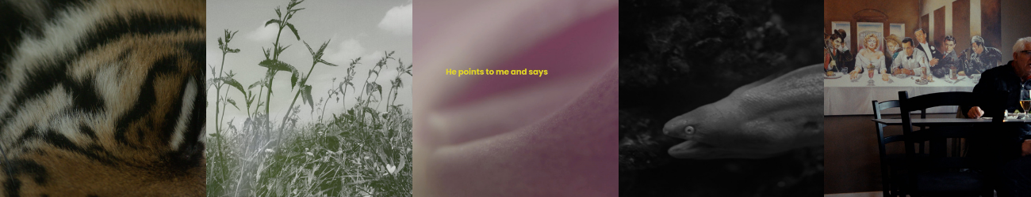
As part of the Short Pitch Program, there will be an interactive workshop titled Navigating the Short Film Circuit – Festivals, Markets & Industry Tips. Designed for film students and emerging filmmakers, the session offers hands-on guidance on what to do after finishing a short film. It will cover how to get your film screened (including distribution and sales strategies, submission platforms, premiere statuses, and working with distributors), how film festivals operate (selection criteria, submission dos and don’ts, and how to make the most of attending festivals), and opportunities for talent development through training and industry programs. The workshop will be led by Emilia Mazik and Mathieu Janssen and will take place on May 10, 2025, at 14:00 at the National Ethnographic Museum, Kredytowa 1.

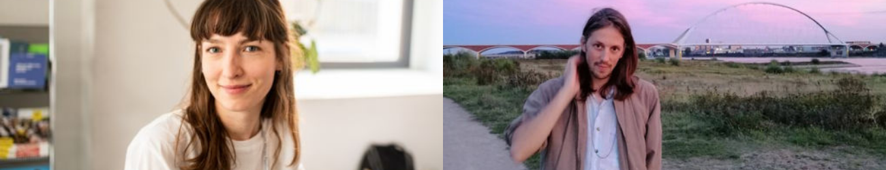

The decision-makers for this year are:
Emilia Mazik (festival representative – Film Fest Gent, Belgium)
Mathieu Janssen (festival representative – Go Short, Netherlands)
Young Woo Kim (festival representative – Red Sea FF / Busan FF, South Korea)
Yorgos Krassakopoulos (festival representative – Thessaloniki Documentary Festival, Greece)
Marina Thome (festival representative – DocLisboa, Portugal)
Ania Trzebiatowska (festival representative – Sundance, USA)
Victoria Leschenko (festival representative – DOK Leipzig, Germany)
Jasper Hokken (festival representative – IDFA, Netherlands)
Yulia Kovalenko (festival representative – DocuDays, Ukraine)
Teresa Morales (festival representative – Punto de Vista, Spain)
Lucie Kon (journalist – BBC Storyville, UK)
Georg Gruber (sales agent – Magnet Film, Germany)
Andy Norton (sales agent – Raina Sales, Finland)
Tim Horsburgh (distributor – National Geographic, USA)
Anas Khelawy (broadcaster – Al Jazeera, Qatar)
Lea Maria Strandbæk Sørensen (organization representative – Nordisk Panorama, Sweden)
Jan Rofekamp (sales agent – freelance / consultations, Greece)
Martijn Te Pas (freelance / consultant – Europadoc, Sweden)
Mateusz Grzesiński (head of documentaries & licensed content – TVP, Poland)
Marta Golba-Naumann (producer, Poland)
Joanna Ruta Baranowska (festival representative, Poland)
Ana Vijdea (producer, Romania)
Eva Sinicaitė (festival representative, Lithuania)
Opal Bennet (producer, USA)

The selected projects can receive the Silver Eye Award. This award for short documentary project is intended to support directors with innovative approaches, authors of films that create social impact, filmmakers who dare to open discussions on serious topics, and creators offering unique points of view. The winner receives a trophy award and a year-long festival distribution service at East Silver Caravan.

MDAG Industry Award Ceremony will take place on May 11 at 21:00 at Kino Kultura.

About the Institute of Documentary Film
Since 2001, the Institute of Documentary Film (IDF) has been supporting Eastern and Central European original documentary films in all stages of production. It assists emerging and experienced directors with the development of their films, and producers with the financing, distribution and promotion of their films, as well as with orientation on the international market. All this with the help of the vast experiences of renowned international experts. Films supported by IDF activities regularly win awards at leading film festivals. For the public, the IDF organises lectures and screenings of the most interesting documentaries not only in cinemas but also in various alternative spaces.

dokweb.net

Media contact:
Anna Jurková | PR IDF | tel.: +420 605 136 254 | e-mail: jurkova@dokweb.net

