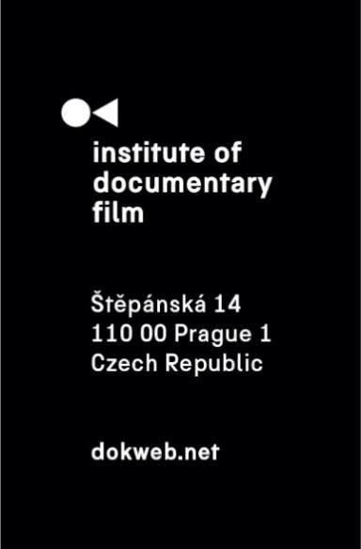
Press Release, Prague, February 7
Join the Ex Oriente Film workshop 2025 – Apply by Feb 28!
The call for applications for the 2025 edition of Ex Oriente Film workshop is open until February 28. This prestigious training program, dedicated to the development of creative documentary feature-length and series projects from Central and Eastern Europe, offers an unparalleled opportunity for filmmakers to refine their projects, receive expert mentorship, and connect with the international film industry.
Since its inception, Ex Oriente Film has been a transformative experience for many filmmakers, equipping them with the tools, insights, and networks needed to bring their documentary visions to life. The workshop consists of three intensive sessions throughout the year, culminating in the opportunity to present projects at the East Doc Platform.
Participants from previous editions highlight the workshop’s profound impact on their careers. Mariia Ponomarova, a participant with the projects Fragile Memory and Nice Ladies, reflects: “Ex Oriente Film workshop is a place to grow as a documentary professional, a place to tackle various uncertainties about your upcoming film and a place to find your community and a support structure that goes beyond the workshop timeline.” Taisiia Kutuzova, director of Shut the Fuck Up!, adds: “The best thing at Ex-Oriente is community of co-minded people who love what they do.”
Many successful projects have emerged from Ex Oriente Film. Most recently, My Armenian Phantoms by Tamara Stepanyan, which is set to world premiere in the Berlinale Forum Special programme at this year’s Berlin International Film Festival. This milestone reflects the workshop’s ability to nurture documentary filmmakers and guide them toward international recognition. Producer at TAG FILM, with films at Sundance and Cannes, Christian Popp reflects on this standout project: “It is a subtle combination of personal and political, intimate and universal resonance and amazing use of archives.”
Other acclaimed projects developed through Ex Oriente Film workshop include Academy Award nominee Rabbit à la Berlin by Bartosz Konopka, Over the Limit by Marta Prus, A Loss of Something Ever Felt by Carlos E. Lesmes or Lessons of Love by Malgorzata Goliszewska and Katarzyna Mateja. All of these films have had successful runs on the international film festival circuit.
Tutors, who are some of the most acclaimed professionals in the documentary world, also emphasize the workshop’s significance. BAFTA-winning filmmaker Marc Isaacs states: “Ex Oriente Film is an innovative and rare chance for filmmakers to receive support in all areas of filmmaking. For many, this is the difference between the life or death of their film.” Similarly, Hanka Kastelicová, VP and Executive Producer of Documentaries for HBO Europe, shares: “Ex Oriente Film is a fantastic opportunity to develop projects, helping filmmakers find the right approach and protagonists. Fully utilizing this opportunity can lead to the success of the film.”
“Ex Oriente Film workshop is great opportunity to rethink your project, to rethink what you really want to tell and understand how to place the project in the international market,” says award-winning screenwriter and documentary director Chris Westendorp. For many, the workshop has been a turning point in their careers. As first-time director Maris Salumets (War on Women) puts it: “Ex Oriente Workshop was a game-changer for my project, helping me refine its vision and successfully bring it to the international market. It not only gave me the confidence to be more ambitious but also connected me with like-minded professionals, many of whom I continue to collaborate with today.”
Aspiring filmmakers are encouraged to seize this opportunity to elevate their projects and join a network of talented documentary professionals. Applications are open until February 28 on dokweb.net.
Ex Oriente Film 2025 Timeline
Ex Oriente Feature Docs
1st Session: June 2025
2nd Session: October 2025
3rd Session & East Doc Forum: March 2026
Ex Oriente Series
1st Session: June 2025
2nd Session: October 2025
3rd Session & East Doc Forum: March 2026
Contact:
Anna Jurková
PR Manager
jurkova@dokweb.net

