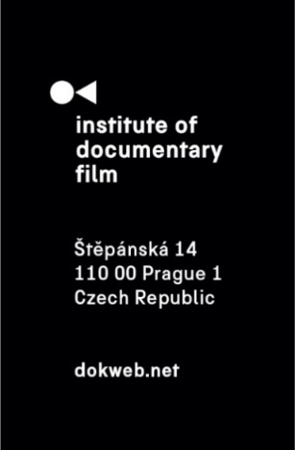
Press Release, Prague, 19. 3. 2025

East Doc Platform 2025 Winners Announced

The awards ceremony marked the end of the East Doc Platform 2025, the largest co-production, financing and distribution platform for Central and Eastern European documentary films, organised by the Institute of Documentary Film in Prague. From March 13-19, a programme for accredited guests from the film industry took place alongside the One World Festival at the French Institute in Prague and other adjacent locations.
In addition to many lectures, sessions and presentations, participants mainly had the opportunity to meet important decision makers of the industry in individual meetings designed to establish valuable collaborations for filmmakers, sponsors and distributors of documentary projects. The programme for the participants culminated with the East Doc Forum, the largest pitching meeting in Central and Eastern Europe, where 25 projects currently in the making were given space for a short presentation and a teaser screening.

The fourteenth edition of the East Doc Platform gave projects the opportunity to win a total of 19 prestigious awards. The winners were announced at the awards ceremony, which definitively closed this year's edition on 19 March at Kino 35 of the French Institute in Prague.

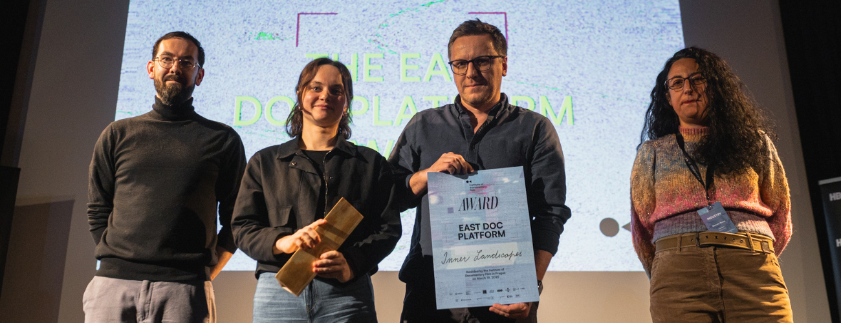
© Institute of Documentary Film – Štěpán Lohr

The main award – the East Doc Platform Award 2025 – annually supporting the best project in development and production, was granted to the Polish project, Zofia Sawicka’s feature film debut Inner Landscapes (dir. Zofia Sawicka, prod. Zofia Kujawska, Maciej Kubicki (Telemark), PL). The jurors Manuela Buono (Slingshot Films), Jess Gormley (Guardian News & Media) and Sara Ferro (MakeDox) have also decided to award a special mention alongside the main winner, which this year goes to the project following the slowly disappearing nomadic lifestyle of a circus family Always Far Away (dir. Roman Ďuriš, prod. Michal Sikora (Lonely Production), Richard Šimeček (Svjetski films), CZ, SK).

Chosen as the winner of this year’s newly added award The Council of Europe Series Co-Production Development Award 2025, the biggest financial support awarded through the platform to date in the value of €50.000, was the project NEAR LIGHT - Second Lives of Murderers (dir. Niccolò Salvato, prod. Mara Cracaleanu (Melancholia Pictures), RO, IT, CZ) revealing the attempts at a second life of people previously convicted of murder. The jurors this year are Michael Kaschner (ZDF – Zweites Deutsches Fernsehen), Barbara Bouillon (ARTE G.E.I.E.) and Alessia Sonaglioni (Council of Europe).

You can read more about this award and the winning project here.

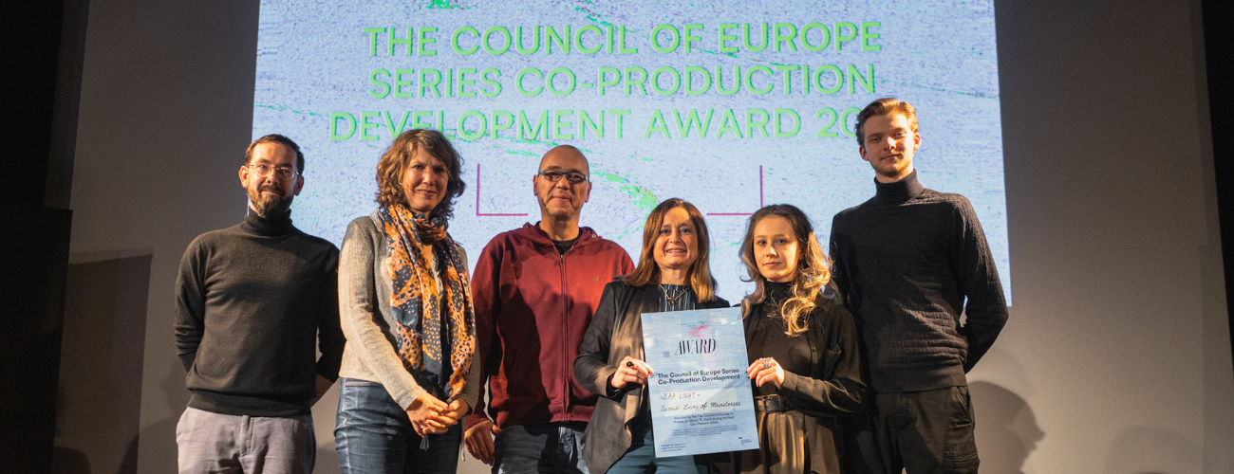
© Institute of Documentary Film – Štěpán Lohr

The Czech Television Award goes to the project Blue Sweater with a Yellow Hole (dir. Tetiana Khodakivska, prod. Elena Saulich (Pronto Film), UA, CZ, DE, FR) about Ukrainian children who have returned from Russian re-education camps. The winner is granted the licence value of 150,000 CZK and an agreement on the subsequent use of the program by Czech Television. The General Partner of the Institute of Documentary Film, HBO, annually chooses the winner of their in the worth of €2.000. The HBO Award this year goes to the project Parallel Space (dir. Martin Piga, prod. Tereza Tokárová (CinePunkt), SK) exploring people’s search for freedom in the modern world.

Congratulations to all of the awarded projects!
See the complete list of the awarded projects and the juries’ statements below:

The East Doc Platform Award: Inner Landscapes (dir. Zofia Sawicka, prod. Zofia Kujawska, Maciej Kubicki (Telemark), PL)
“We give this award to a new voice. The proposal was very affecting and unanimously stood out to the jury members as a love poem that is rooted in global events but elevates through its human connections. The film maker has cleverly curated a thought provoking space of constant transitions taking us on a journey to the very essence of humanity."

The East Doc Platform Award Special Mention: Always Far Away (dir. Roman Ďuriš, prod. Michal Sikora (Lonely Production), Richard Šimeček (Svjetski films), CZ, SK)
“We decided to recognize a special mention to a film that through a long term observation portraits an extra-ordinary coming of age story.”

The Council of Europe Series Co-Production Development Award 2025: NEAR LIGHT - Second Lives of Murderers (dir. Niccolò Salvato, prod. Mara Cracaleanu (Melancholia Pictures), RO, IT, CZ)
“The Council of Europe Series Co-Production development award goes to an exceptional project that gives a voice to individuals struggling to reintegrate into society. The creator's multi-layered approach to their personal stories helps to humanise these individuals. It proposes a moving alternative narrative to the dominant fictional version of murderers in a clear dramatic structure. The award goes to “Near Light – Second Lives of Murderers”

Czech Television Award: Blue Sweater with a Yellow Hole (dir. Tetiana Khodakivska, prod. Elena Saulich (Pronto Film), UA, CZ, DE, FR)
“War crimes do not only take place on the front lines. However, all dimensions of these incredible crimes against humanity are gradually being revealed, also thanks to the work of documentary filmmakers. Among the worst crimes are those committed against children. It is necessary to talk about this. The Czech Television Award therefore goes to the film Blue Sweater With a Yellow Hole, directed by Tetiana Khodakivska, produced by Elena Saulich.”

HBO Award: Parallel Space (dir. Martin Piga, prod. Tereza Tokárová (CinePunkt), SK)
“We are delighted to recognize a project that, despite being in its early stages, already provides a unique perspective on the current generation and their worldview. We appreciate its ability to ask important questions that resonate not only with the younger generation but with society as a whole. We encourage this young and talented team to fully realize the potential of their project, continuing to develop its innovative and fresh approach. The HBO award goes to Parallel Space.”

Al Jazeera Balkans DFF Award: Operation Champion (dir. Mariam Nikolaishvil, prod. Irina Gelashvili (RADIUM FILMS), GE)
“This project explores emotional and physical struggles, highlighting resilience and the hidden cost of success. The contrast between the structured world of sports and the chaotic reality of politics, creates a dilemma of loyalty to community vs political propaganda.”

The Golden Funnel Award:
Docuseries: Sport to the People (dir. Đuro Gavran, prod. Miljenka Čogelja (Pipser), HR)
Feature Docs: Retrospective (dir. Gabrielė Urbonaitė, prod. Uljana Kim, Migla Butkute (Studio Uljama Kim), LT)
Statement from the leading tutor of Ex Oriente Series Ruth Reid: “This award is given to this team who have dedicated themselves to developing this project across our 3 sessions. They have turned all the stones, examined their project, their motivations and even themselves. And I’m so impressed with their journeys and proud of what they’ve managed to achieve during this year. The award of 1.000 EUR goes to Sport to the People and The award of 1.000 EUR goes to Retrospective.”

Cut thru the Noise Award: Virtual Girlfriends (dir. Barbora Chalupová, prod. Pavla Klimešová (Helium Film), CZ, SL, BG)
“Selecting Virtual Girlfriends was an easy decision, not just because of the strong team behind it, but also for its timely exploration of gender roles, the changing nature of financial autonomy, and the ever-evolving state of online interaction. The film promises a compelling look into the world behind OnlyFans, providing valuable insight into the deeper implications of this industry and those who choose to enter it.”

Ex Oriente Fine Cut Award: Be Realistic, Demand the Impossible (dir. Vanja Juranić, prod. Vanja Jambrović, Tibor Keser (Restart), HR)

Silver Eye Award: A Song Without Home (dir. Rati Tsiteladze, prod. Olga Slusareva (ArtWay Film), GE)
“Taking a highly innovative visual approach to its material, this documentary project immerses itself in the emotional and physical flow of a young woman who feels incredibly isolated within her community and is searching for her own space.
Alienated from her parents and cut adrift from the wider society this intimate and strongly felt portrait intersects effectively with the increasingly difficult struggles of LGBTQI+ communities within an evermore conservative and reactionary Georgia.
We have decided to give this year’s Silver Eye Award to Rati Tsiteladze’s A Song Without Home. We hope this award will help the film travel much further across the festival circuit.”

Silver Eye Award Special Mention: What About Petey? (dir. Martin Trabalík, prod. Jan Bodnár (GNOMON PRODUCTION), co-prod. Silvia Panáková (Dayhey), CZ, SK)
“Some projects do not need to do anything demonstrably innovative with documentary form, their strength lies in the honesty and integrity with which they approach their subject matter.
The film project we would like to give a Special Mention to is just that kind of film, giving audiences powerful emotional insight into the ways in which we care for a loved one, even when that loved one presents many obstacles to receiving that love. That film is Martin Trabalik’s What About Petey?”

Millennium Docs Against Gravity Award: Always Far Away (dir. Roman Ďuriš, prod. Michal Sikora (Lonely Production), Richard Šimeček (Svjetski films), CZ, SK)
“We award the Millennium Docs Against Gravity prize to the project Always Far Away, which explores themes of the future, family, and coming of age in difficult, unconventional circumstances. We recognize how challenging it is to create a film about growing up in a marginalized community - one that avoids clichés and authentically captures the nuances of this experience.
Having seen the filmmaker’s previous work, we appreciate his commitment to addressing important themes and developing a unique cinematic voice. We believe in his potential and are confident that this award will support him in furthering their artistic journey.”

Baltic Sea Docs Award: Operation Champion (dir. Mariam Nikolaishvil, prod. Irina Gelashvili (RADIUM FILMS), GE)
“A compelling and multilayered story of ambition and personal dilemmas, a testament to the resilience of the human spirit while simultaneously exposing the societal tensions of a turbulent era. Through the lens of an athlete caught between personal sacrifice and a political system that demands loyalty, the project offers a powerful reflection on the hidden costs of success.”

DocsBarcelona Award: Inner Landscapes (dir. Zofia Sawicka, prod. Zofia Kujawska, Maciej Kubicki (Telemark), PL)
“The project beautifully portrays the complexity of human lives with a tender, sensitive approach, integrating metaphorical elements and different perspectives that resonate with our shared humanity. Its exploration of connection amidst diversity reveals its profound potential. A truly impactful cinematic journey.The DocsBarcelona Award goes to Inner Landscapes.”

DOK Leipzig DOK Co-Pro Market Award: Recovery (dir. Roman Bondarchuk, Vadym Ilkov, prod. Darya Bassel (Moon Man), UA, FR)
“As discussions about Ukraine’s future take place globally—at various events, conferences, and even in negotiation rooms—, the people in Ukraine continue to bravely rebuild their lives and restore their buildings and cities day by day. In recognition of this resilience, we extend our solidarity, admiration, and support to the dedicated and talented directors Roman Bondarchuk and Vadym Ilkov and producer Darya Bassel. The DOK Leipzig DOK Co-Pro Market Award goes to the project Recovery.”

DAE Pitch Talent Encouragement Prize: Sounds of Revolution (dir. Nikoloz Bezhanishvili, prod. Nikoloz Bezhanishvili (NIKADOCFILM), GE)
“DAE's mission has always been to support filmmakers who bring important stories to a wide audience while facing political and financial difficulties. The DAE Pitch Talent Encouragement Prize consists of a tailored consultation with a DAE expert and a one year free membership in our association providing access to resources, networking and community. The project we have chosen shows today's harsh reality through people who fight for democracy and freedom. The award goes to... Sounds of Revolution!”

Pitch the Doc Prize: Frozen Ocean (dir. Viktória Dénes, prod. Julianna Ugrin (Éclipse Film), HU, FR, NO)
“For the project's unique ability to combine the thrill of adventure with the urgent story of climate change and environmental protection. We believe this documentary will take viewers on an exciting and emotional journey, using striking cinematography and powerful storytelling to engage audiences in the conversation and transform passive viewers into active climate advocates.”

Docs Ireland Prize: NEAR LIGHT - Second Lives of Murderers (dir. Niccolò Salvato, prod. Mara Cracaleanu (Melancholia Pictures), RO, IT, CZ)
“This is a daringly innovative and exceptionally promising docu-series / feature-length doc project, that has the potential to create a deeply human portrait of the ways in which people can be successfully reintegrated back into society after committing awful crimes.
We have chosen NEAR LIGHT to receive the Docs Ireland award. It will hopefully benefit from placement within our meet market at the end of June this year.”

Sheffield DocFest Networking Award:
Stitches of Freedom (dir. Alex Shiriaieff, Ivo Briedis, prod. Uldis Cekulis (VFS Films), LV, SE)
“I know that it's a solid team and they do already have Cat & Docs on board, but it's a unique story, daring in the style and extremely timely. With DocFest having queer stories as one of the editorial focuses would fit perfectly and hope they can meet with other potential partners.
A unique human story that tackles questions of identity, freedom and acceptance of the self in a time and in a country when gender reassignment was unthinkable. The project creatively blends archives and recreations following the protagonist's journey and the one of the person who made it possible. More than ever this project is important and timely, allowing the audience to reflect on our society then and now and reminding us of the need to keep fighting for the right to exist as human beings.”

Frozen Ocean (dir. Viktória Dénes, prod. Julianna Ugrin (Éclipse Film), HU, FR, NO)
“Same as above, but considering the budget and what they're looking for I think DocFest could be of help, if they decide to come of course ;) I am also aware that this would involve additional budget both teams
Frozen Ocean is a journey that we might have done in the past but that in those troubled times, both geopolitically and environmentally, is much needed. Retracing the expedition which took place 150 years ago the director reopens a dialogue with people and places, with scientists, locals and landscapes, observing how things have changed and the importance of human cooperation for significant change.”

MIA Market Award: Frozen Ocean (dir. Viktória Dénes, prod. Julianna Ugrin (Éclipse Film), HU, FR, NO)

Sunny Side of the Doc Prize: Blue Sweater with a Yellow Hole (dir. Tetiana Khodakivska, prod. Elena Saulich (Pronto Film), UA, CZ, DE, FR)
"In awarding 'The Blue Sweater with a Yellow Hole,' we recognize a vital documentary of an unfolding tragedy. This project courageously confronts the reality of Russia's ongoing war against Ukraine—not through battlefield footage, but through the eyes of its youngest victims. By transforming children's traumatic experiences into animated testimony, the filmmakers create something uniquely powerful: a witness statement that is both accessible and devastating. At Sunny Side of the Doc, we fulfill our mission by supporting and encouraging international collaborations around these urgent narratives that give voice to stories the world needs to hear and see." Aurélie Reman, Managing Director of Sunny Side of the Doc

About the Institute of Documentary Film
Since 2001, the Institute of Documentary Film (IDF) has been supporting Eastern and Central European original documentary films in all stages of production. It assists emerging and experienced directors with the development of their films, and producers with the financing, distribution and promotion of their films, as well as with orientation on the international market. All this with the help of the vast experiences of renowned international experts. Films supported by IDF activities regularly win awards at leading film festivals. For the public, the IDF organises lectures and screenings of the most interesting documentaries not only in cinemas but also in various alternative spaces.

dokweb.net

Media contact:
Anna Jurková | PR IDF | tel.: +420 605 136 254 | e-mail: jurkova@dokweb.net

