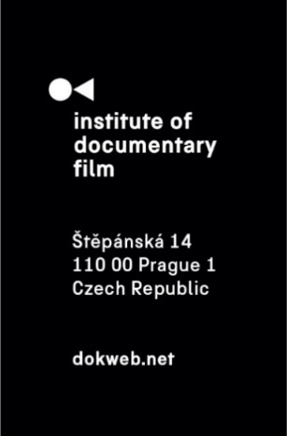
Press Release, Prague, 19. 3. 2025

The Council of Europe Series Co-Production Development Award 2025 goes to NEAR LIGHT - Second Lives of Murderers

The fourteenth edition of the East Doc Platform has been selected as one of only three European film markets to host the prestigious Council of Europe Series Co-Production Development Award 2025. We are proud and honored to be part of this initiative alongside two other esteemed film markets: CineLink Drama (Bosnia and Herzegovina) and TV Beats Co-Financing Market – Industry@Tallinn (Estonia).

The winner was announced as part of the closing awards ceremony on the final day of this year’s edition, March 19, at the French Institute in Prague. The jury, consisting of Michael Kaschner (ZDF – Zweites Deutsches Fernsehen), Barbara Bouillon (ARTE G.E.I.E.), and Alessia Sonaglioni (Council of Europe), decided to award the project NEAR LIGHT – Second Lives of Murderers (dir. Niccolò Salvato, prod. Mara Cracaleanu, Melancholia Pictures, Romania, Italy, Czech Republic). This project, created by young and talented filmmakers, follows three protagonists who each carry the dreadful past of having been convicted of murder. The series offers a unique perspective, highlighting the humanity of its protagonists and their struggles as they attempt to reintegrate into society.


© NEAR LIGHT – Second Lives of Murderers

The jury accompanied their decision with the following statement:

“The Council of Europe Series Co-Production development award goes to an exceptional project that gives a voice to individuals struggling to reintegrate into society. The creator's multi-layered approach to their personal stories helps to humanise these individuals. It proposes a moving alternative narrative to the dominant fictional version of murderers in a clear dramatic structure. The award goes to NEAR – Second Lives of Murderers.”

About the Award
The Council of Europe Series Co-Production Development Award 2025 is intended to foster creative collaborations in series co-production and empower independent producers and comes in the form of a financial support of €50,000. Through the Pilot Programme for Series Co-productions, under which the award was created, the CoE points at providing recognition and access to crucial market exposure to talented independent producers.

We thank the Council of Europe for their recognition of the East Doc Platform as an important part of the European documentary film industry and we hope to continue our collaboration in the future years.

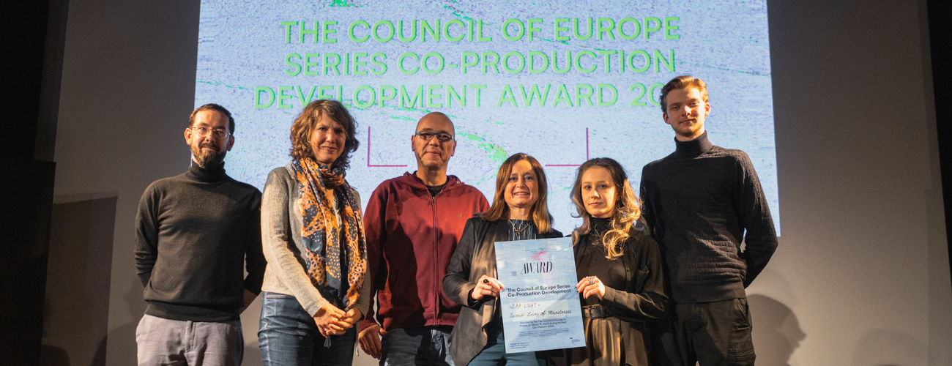
© Institute of Documentary Film – Štěpán Lohr

About the Institute of Documentary Film
Since 2001, the Institute of Documentary Film (IDF) has been supporting Eastern and Central European original documentary films in all stages of production. It assists emerging and experienced directors with the development of their films, and producers with the financing, distribution and promotion of their films, as well as with orientation on the international market. All this with the help of the vast experiences of renowned international experts. Films supported by IDF activities regularly win awards at leading film festivals. For the public, the IDF organises lectures and screenings of the most interesting documentaries not only in cinemas but also in various alternative spaces.
dokweb.net

Media contact:
Anna Jurková | PR IDF | tel.: +420 605 136 254 | e-mail: jurkova@dokweb.net

