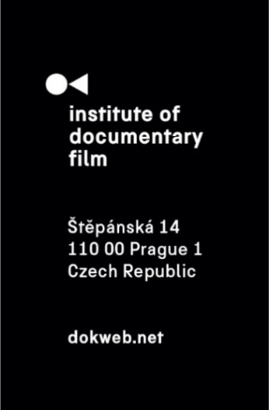
Press Release, Prague, 19. 9. 2025

East Doc Platform 2026 launches its call for projects

The Institute of Documentary Film invites filmmakers to submit their projects to the 15th edition of East Doc Platform (EDP), taking place from March 19–25, 2026 in Prague. As the largest documentary industry event in Central and Eastern Europe, EDP offers unparalleled opportunities to present projects, meet key industry decision-makers, and gain international exposure.

Why submit to East Doc Platform?
East Doc Platform is the region’s largest co-production, funding, and distribution event, connecting filmmakers with producers, broadcasters, distributors, festival programmers, and sales agents from around the world. Projects at all stages – from early development to rough cuts and completed films – are matched with activities tailored to their needs, including:
- East Doc Forum: A flagship pitching platform for feature-length documentaries and factual series, supported by a five-day training programme and one-on-one meetings with potential co-producers, financiers, and partners.
- East Doc Market: A curated marketplace where projects – whether in development, rough cut, or final form – meet distributors, sales agents, and other decision-makers in tailored one-on-one meetings.
- Czech Docs: Coming Soon...: A special showcase of upcoming Czech documentaries, presented to festival selectors, sales agents, distributors, and the general public.

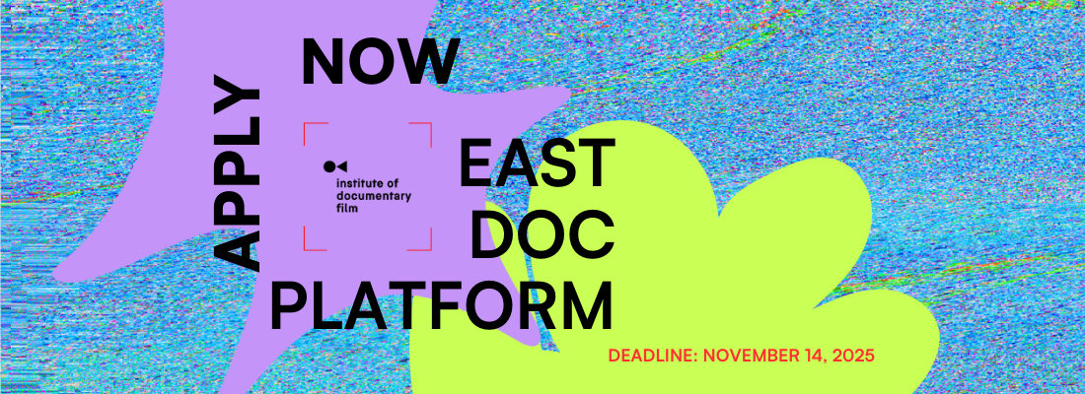

Eligibility
EDP welcomes creative feature-length documentary films or factual series projects from Central and Eastern Europe in development, production, or post-production stage, as well as finished short and feature films. The selection is also open to the international productions with projects thematically linked to the CEE region.
You can find the list of eligible countries for submissions here.

Key Dates
- November 14, 2025: Submissions deadline
- January 15, 2026: Successful applicants informed
- March 19–25, 2026: East Doc Platform in Prague, Czech Republic
  - March 23: East Doc Market (rough cuts & completed films)
  - March 24: East Doc Forum presentations
  - March 24–25: East Doc Market (projects in development and Forum meetings)

How to apply
Filmmakers can apply with either:
- An upcoming project (development, production, post-production)
- A completed film (rough cuts, finished films)

Applications are open until November 14, 2025. Detailed guidelines and submission forms can be found on our website: https://dokweb.net/activities/east-doc-platform/2026/call-for-entries. For inquiries, contact Veronika Janatková, Programme Director at janatkova@dokweb.net.

About East Doc Platform
Organized by the Institute of Documentary Film in association with the One World International Human Rights Film Festival, East Doc Platform is the most important meeting place for the documentary industry in Central and Eastern Europe. Over the years, it has supported hundreds of acclaimed projects that went on to achieve international recognition. The next edition of the East Doc Platform will take place from March 19 to 25, 2026.

Read more here: https://dokweb.net/activities/east-doc-platform/2026/about



About the Institute of Documentary Film
Since 2001, the Institute of Documentary Film (IDF) has been supporting Eastern and Central European original documentary films in all stages of production. It assists emerging and experienced directors with the development of their films, and producers with financing, distribution, and promotion of their films, as well as with orientation on the international market. All this with the help of the vast experiences of renowned international experts. Films supported by IDF activities regularly win awards at leading film festivals. For the public, the IDF organises lectures and screenings of the most interesting documentaries not only in cinemas but also in various alternative spaces.
dokweb.net

Media contact:
Anna Jurková | PR IDF | tel.: +420 605 136 254 | e-mail: jurkova@dokweb.net

