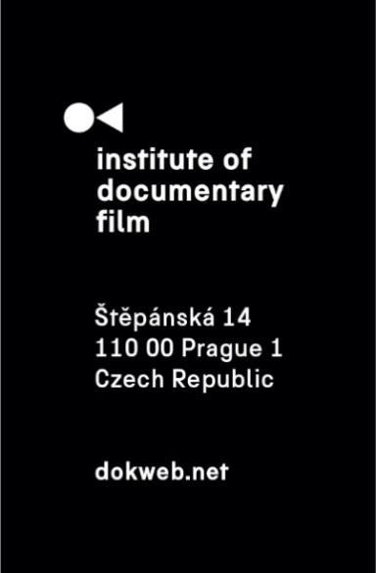
Press Release, Prague, December 1, 2025
Applications are now open for the 2026 Short Pitch Program at Millennium Docs Against Gravity
Institute of Documentary Film, in cooperation with Millennium Docs Against Gravity, is pleased to announce the opening of submissions for the 2026 Short Pitch Program. Emerging documentary filmmakers from Central and Eastern Europe are invited to submit their short documentary projects ahead of the February 1, 2026 deadline. The program will take place during the 23rd edition of Millennium Docs Against Gravity in Warsaw in May 2026.
The Short Pitch Program is designed to support the next generation of documentary talent from the region, focusing on short films of up to 25 minutes that are currently in development or in the rough-cut stage. Seven projects will be selected to take part in this tailored pitching initiative. Applicants are encouraged to carefully review all guidelines and verify eligibility before submitting their projects. Submitting to the program is free of charge.
Selected filmmakers will begin with online pitch training to help them refine the artistic vision, structure, and presentation of their works. During the festival in Warsaw, participants will pitch their projects to a distinguished industry panel composed of sales agents, distributors, festival programmers, and representatives from television networks. Following the pitch session, they will also take part in individual meetings, offering a unique opportunity for professional feedback, networking, and future collaboration.
An international jury will present the Silver Eye Award to the most outstanding documentary project featured in the Short Pitch Program. This prestigious recognition honors filmmakers who demonstrate innovative storytelling, a strong authorial voice, and the ability to engage with impactful or challenging themes from a distinctive perspective. The award includes a full year of festival distribution services provided by East Doc Caravan, giving the winning film an invaluable opportunity to reach international audiences.
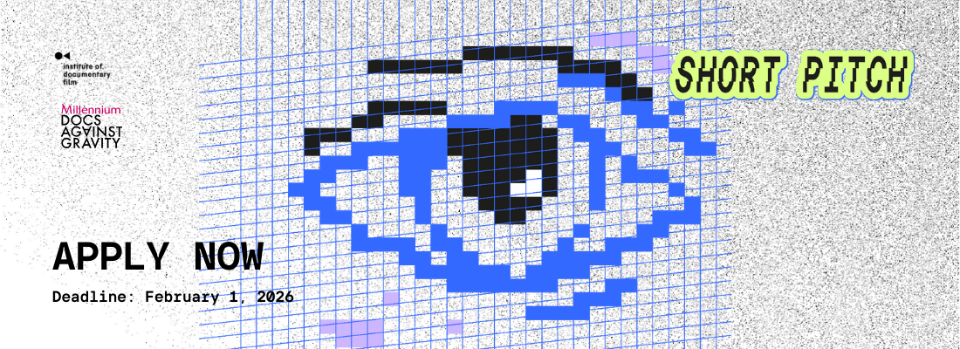
Key deadlines:
- Application deadline: February 1, 2026
- Notification of results: March 2, 2026
- Program dates: May 2026 during Millennium Docs Against Gravity (exact date TBA)
For more details and application, visit: https://dokweb.net/activities/east-doc/2026/short-pitch-program0
About the Institute of Documentary Film
Since 2001, the Institute of Documentary Film (IDF) has been supporting Eastern and Central European original documentary films in all stages of production. It assists emerging and experienced directors with the development of their films, and producers with the financing, distribution and promotion of their films, as well as with orientation on the international market. All this with the help of the vast experiences of renowned international experts. Films supported by IDF activities regularly win awards at leading film festivals. For the public, the IDF organises lectures and screenings of the most interesting documentaries not only in cinemas but also in various alternative spaces.
dokweb.net

Media contact:
Anna Jurková | PR IDF | tel.: +420 605 136 254 | e-mail: jurkova@dokweb.net

