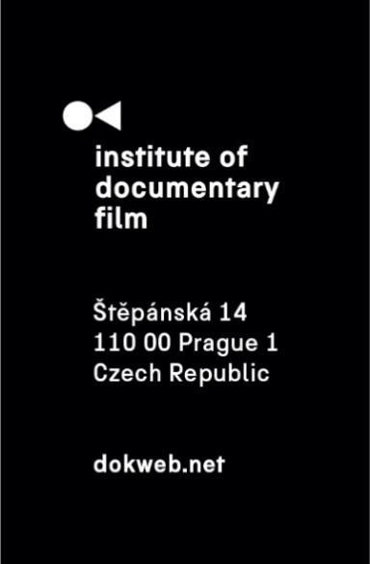
Press Release, Prague, February 7
Last Chance to Join the Short Pitch Program at Millennium Docs Against Gravity
The final opportunity to apply for the Short Pitch Program 2025 is approaching. Taking place on May 10, 2025, in Warsaw, Poland during Millenium Docs Against Gravity, the program is open to short documentary films (up to 25 minutes) from Central and Eastern Europe that are in the development or rough-cut stage. Five selected projects will be presented to a distinguished panel of sales agents, distributors, festival or TV representatives.
The Short Pitch Program provides filmmakers with valuable industry feedback, exposure, and networking opportunities, helping them advance their projects and connect with key decision-makers in the documentary film industry. The selection process prioritizes both artistic merit and impactful storytelling. In addition to gaining industry exposure, participants compete for prestigious awards:
- The Silver Eye Award, which includes a trophy and a year-long festival distribution service through East Silver Caravan.
- The DAE Pitch Talent Encouragement Prize, offering tailored mentoring from an industry expert.
Previous participants have described the program as a pivotal moment in their filmmaking journey.
Marta Smerechynska, director of Children Will Forget who participated in this program in 2023, reflected: “Familiar with the world of feature films, starting to work on shorts left me feeling lost. The Short Pitch Program became a unique opportunity to connect with professionals specifically interested in short films and explore possibilities for all my ongoing films, both completed and in progress.”
Andreea Udrea, director of The Wind Blows Where It Pleases who also participated in 2023, emphasized the program’s role in shaping her film: “The Short Pitch Program helped me refine my project, making it both intimate and relatable. It also encouraged me to keep working on my story, as many programmers and distributors recognized its significance and its challenge to societal expectations.”
Marta Szymanowska, producer of Hidden who participated last year, highlighted the program’s collaborative spirit: “The Short Pitch Program offers a rare opportunity for short film creators to step outside their own perspective and engage with potential audiences. We received valuable feedback from industry professionals, some of whom we remained in contact with when the festival selection period for the film began.”
Applications must be submitted by February 21, 2025. The application process is free of charge.
For more details and to apply, visit dokweb.net.
About the Short Pitch Program
The Short Pitch Program supports short documentary films from Central and Eastern Europe, fostering the development of exceptional projects by offering a platform for filmmakers to engage with industry professionals and receive constructive feedback.
Contact:
Anna Jurková
PR Manager
jurkova@dokweb.net

