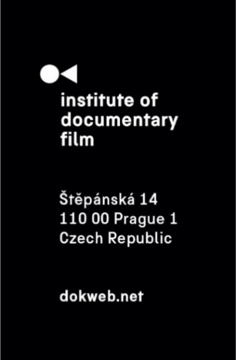
Press Release, Prague, 6. 5. 2026

Short Pitch Program 2026 returns to Warsaw showcasing emerging documentary talent from Central and Eastern Europe

The Short Pitch Program 2026 will take place on May 10 in Warsaw as part of the Millennium Docs Against Gravity festival, once again positioning the city as a vibrant hub for emerging documentary filmmakers from across Central and Eastern Europe.

Organized by the Institute of Documentary Film in cooperation with Millennium Docs Against Gravity, the program provides a dynamic platform for new voices in short documentary filmmaking. It brings together selected creative teams and leading industry professionals, including sales agents, distributors, and festival representatives, to foster collaboration and support innovative storytelling in the region.

This year’s edition features seven carefully selected projects representing a diverse range of themes, styles, and perspectives. Each team will present their project in an 8-minute pitch, followed by a Q&A session with industry experts. The pitching session will be moderated by Emilia Mazik and will take place at the National Ethnographic Museum in Warsaw.

In preparation for the event, participants took part in a collective online training session on April 17, where they refined their storytelling and presentation skills through peer exchange and expert feedback.

The program will open with the pitching session and continue with a panel discussion titled Against Despair: Short Documentaries as Acts of Resistance, exploring how contemporary filmmakers respond to political and social challenges. The panel will feature acclaimed speakers Alisa Kovalenko, Anne Gaschütz, and Anas Sareen.

In the afternoon, participants will attend the Pole Position pitching of completed Polish films, followed by one-on-one meetings with invited decision-makers. These meetings offer valuable opportunities for direct dialogue and potential future collaborations.

The day will conclude with an award ceremony recognizing outstanding projects. Awards include:
- East Doc Award, offering tailored distribution support and festival strategy
- Documentary Association of Europe Award, including a consultancy session with a senior expert
- Polish Filmmakers Association Award, a cash prize of PLN 5,000
- Rising Doc Producer Award, providing mentorship from an experienced industry professional

Selected Projects – Short Pitch Program 2026:
- Event horizon (dir. Jakub Gomółka, Poland)
- Kyiv Under My Wheels (dir. Marina Baibarza, Ukraine/Poland)
- Lefek (dir. Tomasz Misiukiewicz, Poland)
- Naples, Florida (dir. Modesta Žemgulytė, Lithuania)
- Bell Boy (dir. Akseli Leppänen, Estonia)
- Victory Day (dir. Wojciech Węglarz, Poland/Norway)
- Last crime we don’t remember (dir. Barbora Venclová & Mariana Kozáková, Czech Republic)

The Short Pitch Program is organized by the Institute of Documentary Film in cooperation with Millennium Docs Against Gravity, in partnership with the Documentary Association of Europe (DAE), Krajowa Izba Producentów Audiowizualnych, and the Polish Filmmakers Association.

About the Institute of Documentary Film
Since 2001, the Institute of Documentary Film (IDF) has been supporting Eastern and Central European original documentary films in all stages of production. It assists emerging and experienced directors with the development of their films, and producers with the financing, distribution and promotion of their films, as well as with orientation on the international market. All this with the help of the vast experiences of renowned international experts. Films supported by IDF activities regularly win awards at leading film festivals. For the public, the IDF organises lectures and screenings of the most interesting documentaries not only in cinemas but also in various alternative spaces.
dokweb.net

Media contact:
Anna Jurková | PR IDF | tel.: +420 605 136 254 | e-mail: jurkova@dokweb.net

