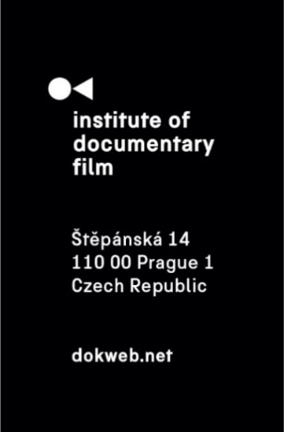
Press Release, Prague, 12. 3. 2026

East Doc Platform returns to Prague with a programme focused on audiences, power, and the future of documentary film

The 15th edition of East Doc Platform will take place in Prague from March 19 to 25 at the French Institute in Prague. Organised by the Institute of Documentary Film in cooperation with the One World Festival, the industry platform once again opens part of its programme to the public through talks, screenings, and discussions exploring contemporary documentary filmmaking.

This year’s programme focuses on questions shaping the field today – from audience engagement and distribution to creative practice and changing industry structures.

Full programme details and access information can be found here.

The opening panel, Reaching the Next Generation: Distribution Strategies for Young Audiences, examines how filmmakers and distributors can connect with younger viewers across festivals, cinemas, digital platforms, and educational contexts. Audience engagement continues throughout the programme in lectures by Paul Rieth and Dimitra Kouzi, who explore how audience strategy can be integrated into documentary development and outreach.

The keynote Languaging Documentary Film by curator and producer Caroline Libresco reflects on how the meaning of “documentary” has expanded in recent years and proposes ways of discussing the form as an art practice. Filmmaking craft is further explored in the lecture Editing as Directing, in which Austrian editor and filmmaker Michael Palm reflects on the creative relationship between editor and director.

Two masterclasses highlight distinctive documentary approaches. Croatian filmmaker Igor Bezinović presents his European Documentary Award–winning film Fiume o morte! and discusses its participatory production process. Serbian director Mila Turajlić shares insights from her long-term research project Non-Aligned Newsreels and her films Non-Aligned and Ciné-Guerillas: Scenes from the Labudović Reels, exploring the creative and production challenges of archive-based filmmaking. Her film Non-Aligned: Scenes from the Labudović Reels will also screen during the programme.

The industry-focused sessions address distribution and financing. International sales agent Anna Berthollet (Lightdox) presents an overview of world sales and distribution strategies for creative documentaries, while producer and International Media Support adviser Henrik Underbjerg introduces a value-based model for international co-productions that allocates rights according to partners’ contributions.

Several events are open to the public without accreditation. From March 21 to 24, the gallery of the French Institute hosts VR screenings of 21-22 CHINA by Thierry Loa and Fresh Memories: The Look by Ondřej Moravec and Volodymyr Kolbasa. The programme also includes Czech Docs: Coming Soon, presenting five upcoming Czech documentary projects, and the East Doc Caravan Showcase, followed by a screening of In Hell with Ivo by Kristina Nikolova, winner of the Jury Award at the Sarajevo Film Festival 2025.

The programme concludes with a session by Marion Schmidt introducing the international #DocSafe initiative, which addresses safety, accountability, and power dynamics within the documentary industry.

Partners
The East Doc Platform is made possible thanks to the financial support of Creative Europe MEDIA, Czech Audiovisual Fund, Ministry of Culture Czech Republic, the capital city of Prague, APA - Audiovisual Producers' Association, Czech-German Future Fund, HBO, Creative Europe Desk Czech Republic and the Austrian Cultural Forum.
The general media partner is the Czech television.
The event is held in cooperation with the One World Film Festival and the French Institute in Prague.

About the Institute of Documentary Film
Since 2001, the Institute of Documentary Film (IDF) has been supporting Eastern and Central European original documentary films in all stages of production. It assists emerging and experienced directors with the development of their films, and producers with the financing, distribution and promotion of their films, as well as with orientation on the international market. All this with the help of the vast experiences of renowned international experts. Films supported by IDF activities regularly win awards at leading film festivals. For the public, the IDF organises lectures and screenings of the most interesting documentaries not only in cinemas but also in various alternative spaces.
dokweb.net

Media contact:
Anna Jurková | PR IDF | tel.: +420 605 136 254 | e-mail: jurkova@dokweb.net

