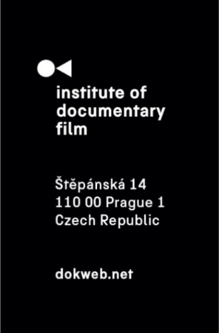
Press Release, Prague, 17. 02. 2025

East Doc Platform 2025 – Still Human?

The Institute of Documentary Film (IDF) in Prague is organizing the 14th edition of The East Doc Platform (EDP), the largest platform for documentary film professionals in Central and Eastern Europe. Alongside with the annual One World International Human Rights Film Festival, the EDP program will take place on the 13-19 March 2025 at the French Institute in Prague, presenting upcoming projects from Czech and international documentary production and offering a platform for creators, sponsors, distributors and other professionals of the documentary industry.

This year's theme Still Human? responds to the current ethical issue of using artificial intelligence and new technologies in storytelling. The theme also invites the audience to explore the relationship between engaging technology and preserving humanity in a world where human rights issues are increasingly reduced to mere statistics and data. How we are truly connected to what is happening around us is also explored in the sub-theme of this year's platform, Are You Still Here?. After all, the question we all know from streaming platforms resonates not only in the context of online content consumption.
"With this year's theme, we wanted to respond to technological changes that have a radical impact on the world around us, whether positive or negative. Unfortunately, we see more of the latter. It's not just AI, but especially the impact of social media on democracy, the growing propaganda and manipulation of public opinion that comes with it. To what extent are we still human, to what extent are we just food for algorithms? But also, to what extent are we still able to be empathetic to our surroundings and to what extent are we worn down by the information overload around us? This is also what we want to explore with this year's EDP theme," says Zdeněk Blaha, Programme Director of the IDF.
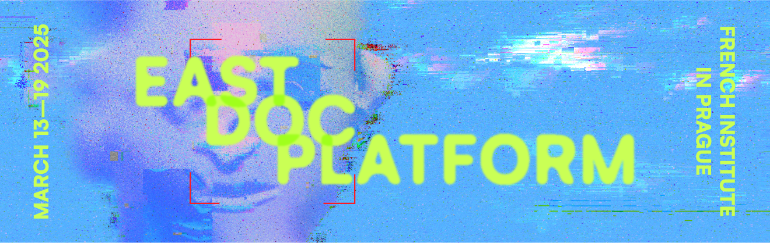

This year's awards
Projects presented at this year's East Doc Platform can, as every year, receive prestigious awards, which entail support in the form of funding, consultations with experts, support in the distribution of the project or, as in the case of the Czech Television Award, a contract with a public television station. Some awards are also granted by prestigious international festivals such as DOK Leipzig or DocsBarcelona, offering the winners the opportunity to present their project on these platforms.

An attractive new addition to this year's awards programme is The Council of Europe Series Co-Production Development Award 2025, supported by the Council of Europe, offering a financial support of €50,000 to the selected project with the aim of promoting cooperation in the field of documentary series co-production. As every year, the main prize of the platform is The East Doc Platform Award, whose winner will be announced together with the winners of the other prizes at the closing ceremony on the last day of the event on March 19.

A list of all selected projects is available on our website here.

Open Programme
EDP also organises an annual open programme for the public, which does not require accreditation and can therefore be enjoyed at the French Institute by anyone. The events are held in English and admission is free. The programme will begin on Friday March 14 at 4 PM with a lecture by former DOK Leipzig Festival Director Claas Danielsen, who will share his observations and experiences when it comes to developing, financing and distributing ambitious films and series for an international audience.

On Saturday morning at 9:30, the programme continues with a panel discussion with the creators of Mr. Nobody against Putin, a successful Danish-Czech co-produced documentary that is also selected in international competition of One World Film Festival in Prague this year. On the same day, in the afternoon from 5:30 PM, the acclaimed film editor and lecturer Jesper Osmund will lead the Pitch Trailer Seminar, showing you examples how to create a successful pitching trailer. On Sunday, a panel on Archives, Ethics & AI will take place at 9:30 AM, where Lucie Králová (Future Memory Lab) and Stephen Bergson (APA, archival researcher) will present APA initiatives in the field of generative artificial intelligence.

The programme continues Monday March 17 with two events for the public. Screening: VR films, a two-day event showing the immersive experience of screening a film in virtual reality, happens at 3:00-7:00 PM, with the second part taking place the following day at the same time. In addition, on Monday at 5:30, there will be a special event focused on Czech documentary filmmaking Czech Docs: Coming Soon…, moderated by Ivana Formanová, manager of the alternative documentary distribution project KineDok.

On Tuesday evening at 6 PM, visitors can listen to the KineDok Conference: New Opportunities for VR Distribution on the topic of new opportunities and ways to distribute films using virtual reality. On the last day, Wednesday March 19, at 15:00, the open programme will be concluded with a panel discussion entitled ALL THE MONEY FOR CULTURE. Film industry representatives from the Czech Republic, Slovakia, Poland and Hungary will discuss specific opportunities for state funding for the film sector within the Visegrad Four region.

A detailed description of the Open Programme is available on our website here.

East Doc Forum
Accredited visitors of the EDP have the opportunity to attend the East Doc Forum event on March 18 from 9 AM at Kino 35. It is the largest pitching event in Central and Eastern Europe, which has been supporting documentary filmmaking in the region for more than 20 years. A total of 25 projects have been selected to present their work to key international representatives of the film industry. Some of these projects were created with the support of the annual Ex Oriente Film workshop, an international film workshop organised by the Institute of Documentary Film, which culminates by presenting each project to an industry audience as part of the East Doc Forum event.

What's new in Czech documentary filmmaking?
Every year, the East Doc Platform focuses also on Czech documentary films. Czech upcoming documentary projects have been selected for each of the three main events (East Doc Forum, East Silver Market and East Doc Market), and as every year, the EDP also hosts a special event Czech Docs: Coming Soon…, this year held on Monday March 17. The event is open to all, and admission is free. During the presentation, five exceptionally attractive Czech feature documentaries with upcoming premieres will be presented. The platform uses this event to support the creators in finding partners or contacts for international distribution and financing.

The event is organized in cooperation with the Audiovisual Producers’ Association (APA).

Film markets at EDP
In addition, also for accredited visitors only, two film markets will take place during EDP this year: the East Silver Market (17 March), a market for finished films and rough cuts, where selected filmmakers meet with key industry decision-makers about distribution and promotion of their projects, and the East Doc Market (March 18-19), where talented filmmakers have the opportunity to participate in over 400 face-to-face meetings with more than 70 international sponsors, broadcasters, distributors, sales agents and festival representatives.

About the Institute of Documentary Film
Since 2001, the Institute of Documentary Film (IDF) has been supporting Eastern and Central European original documentary films in all stages of production. It assists emerging and experienced directors with the development of their films, and producers with the financing, distribution and promotion of their films, as well as with orientation on the international market. All this with the help of the vast experiences of renowned international experts. Films supported by IDF activities regularly win awards at leading film festivals. For the public, the IDF organises lectures and screenings of the most interesting documentaries not only in cinemas but also in various alternative spaces.

dokweb.net

Media contact:
Anna Jurková | PR IDF | tel.: +420 605 136 254 | e-mail: jurkova@dokweb.net

