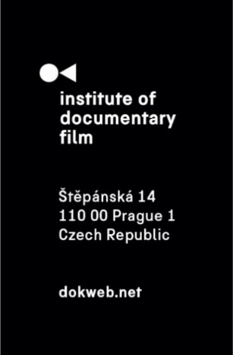
Press Release, Prague, 16. 5. 2025

Ex Oriente Film 2025 kicks off with 17 bold documentary projects and renowned industry tutors

In just a few weeks, the new edition of Ex Oriente Film—a leading training program for creative documentary development powered by the Institute of Documentary Film —will launch its 2025 cycle, supporting some of the most promising film talents from Central and Eastern Europe. This year’s program includes 12 feature-length documentaries and 5 documentary series in development or early production stage, selected from 17 countries.
The Ex Oriente Film workshop is divided into two tracks: Ex Oriente Features and Ex Oriente Series. Participants will attend three intensive residential workshops held across Europe, focusing on story structure, visual style, production strategy, co-productions, and festival positioning. The cycle culminates with a final pitching session at the East Doc Forum during the East Doc Platform 2026 in Prague.

The first workshop session for Ex Oriente Features will take place June 16–20, 2025, in Sheffield, UK, in partnership with Sheffield DocFest. The first Ex Oriente Series session follows June 22–24, 2025, in La Rochelle, France, in collaboration with Sunny Side of the Doc. Additional sessions are scheduled for Sibiu, Brno, and Prague. Full timeline details are available on our website.

Selected projects
This year’s lineup includes powerful and diverse stories tackling urgent social issues, identity, history, and resistance. Among the selected documentary features are:

- Not so far away places (dir. Renato Borrayo Serrano, Yulia Vishnevets)
- My Dear Vira (dir. Olga Chernykh, Maryna Brodovska)
- House in a Bottle (dir. Anna Morawiec)
- +7: Scamming for Revenge (working title) (dir. Oleksandra Horiienko)
- Shape of Silence (dir. Varun Trikha)
- Children of the Moon Land (dir. Roman Ďuriš)
- Dance with Me (dir. Leila Basma)
- I had a Dream about an Elephant (dir. Štefan Straka)
- Symphony of Seasons (dir. Sami Mustafa)
- Dekonstrukt (dir. Mateusz Góra, Kamil Wilk)
- VESNA FOREVER VESNA (dir. Hana Piscevic, Nebojsa Resanovic)
- At Home (dir. Tamara Todorović)

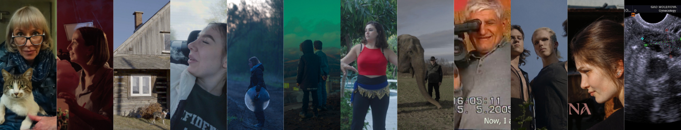

Selected docuseries include:

- Hijacked Life (dir. Andrius Lekavičius)
- Grandpa was a genius (dir. Kalina Nikolova)
- World Divided (dir. Soňa Nôtová, Štefan Straka)
- Justice as Legalised Terror (dir. Zora Cejnková)
- When The Wind Blows (dir. Anna Savchenko)

Read more about this year’s projects here.

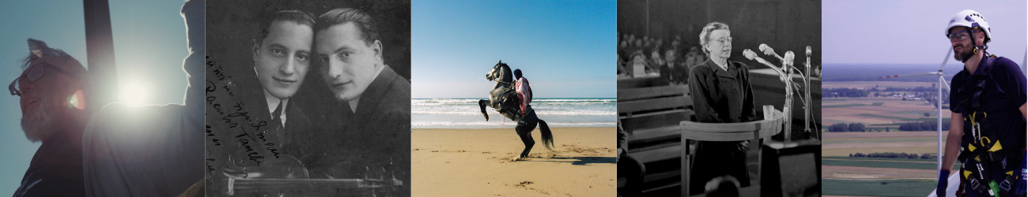

Expert tutors
The 2025 edition will be guided by an outstanding group of tutors from across the international documentary scene. The leading tutors are: producer and consultant Gitte Hansen, filmmaker and co-founder of the Institute of Documentary Film Filip Remunda, director and Czech Television’s Head of Documentaries Ivana Pauerová Miloševičová, award-winning Syrian-German filmmaker and producer Diana El Jeiroudi, and producer and former ARTE commissioning editor Christian Popp. The Ex Oriente Series program will be led by experienced producer Ruth Reid, who worked in-house at HBO and Netflix. Guest tutors for this edition include Mark Edwards, Chris Westendorp, Mikael Opstrup, Gianluca Matarrese, Margje de Koning, and Khadidja Benouataf, with more names to be announced soon.

Read more about this year’s tutors here.

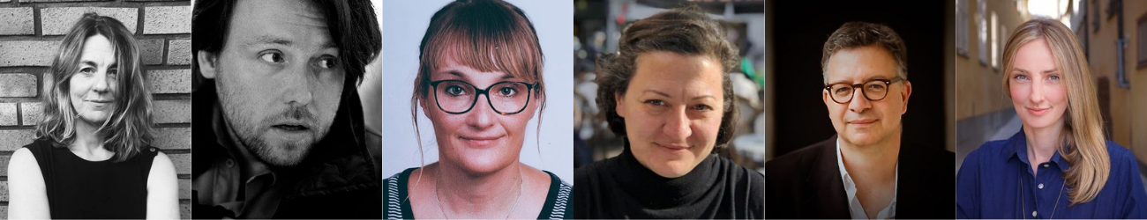

Ex Oriente Film 2025 is made possible with the support of Creative Europe MEDIA, the Czech Audiovisual Fund, and the Ministry of Culture of the Czech Republic.

About the Institute of Documentary Film
Since 2001, the Institute of Documentary Film (IDF) has been supporting Eastern and Central European original documentary films in all stages of production. It assists emerging and experienced directors with the development of their films, and producers with the financing, distribution and promotion of their films, as well as with orientation on the international market. All this with the help of the vast experiences of renowned international experts. Films supported by IDF activities regularly win awards at leading film festivals. For the public, the IDF organises lectures and screenings of the most interesting documentaries not only in cinemas but also in various alternative spaces.

dokweb.net

Media contact:
Anna Jurková | PR IDF | tel.: +420 605 136 254 | e-mail: jurkova@dokweb.net

