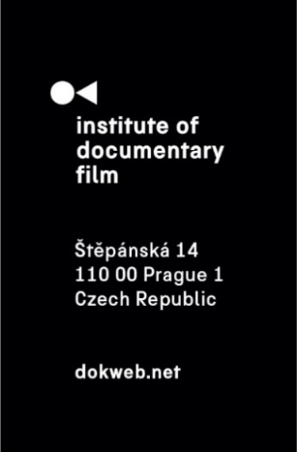
Press Release, Prague, 4. 7. 2025

Ex Oriente Documentary Laboratory launched its new edition in Sheffield and La Rochelle

In June, the first sessions of this year’s Ex Oriente Features and Ex Oriente Series workshops took place – marking the opening chapter of a three-part journey dedicated to supporting bold documentary storytelling from Central and Eastern Europe. In Sheffield and La Rochelle, our participants came together to begin shaping their projects under the guidance of leading international tutors.

1st session of Ex Oriente Features at Sheffield DocFest
For the first time ever, we partnered with Sheffield DocFest and hosted the opening five-day session from June 16-20. Twelve selected feature documentary projects entered an intensive programme combining group workshops, individual consultations and tailored development tracks for both directors and producers. Led by Gitte Hansen, Filip Remunda, Ivana Pauerová Miloševičová, Diana El Jeiroudi, and Christian Popp, the workshop was further enriched by masterclasses and insights from distinguished guest tutors including Anita Rehoff Larsen, Mikael Opstrup, Margje de Koning, Khadidja Benouataf, Gianluca Matarrese, Henrik Underbjerg, Mike Lerner, Marc Isaacs, Olha Bregman, and Dominic Lees.

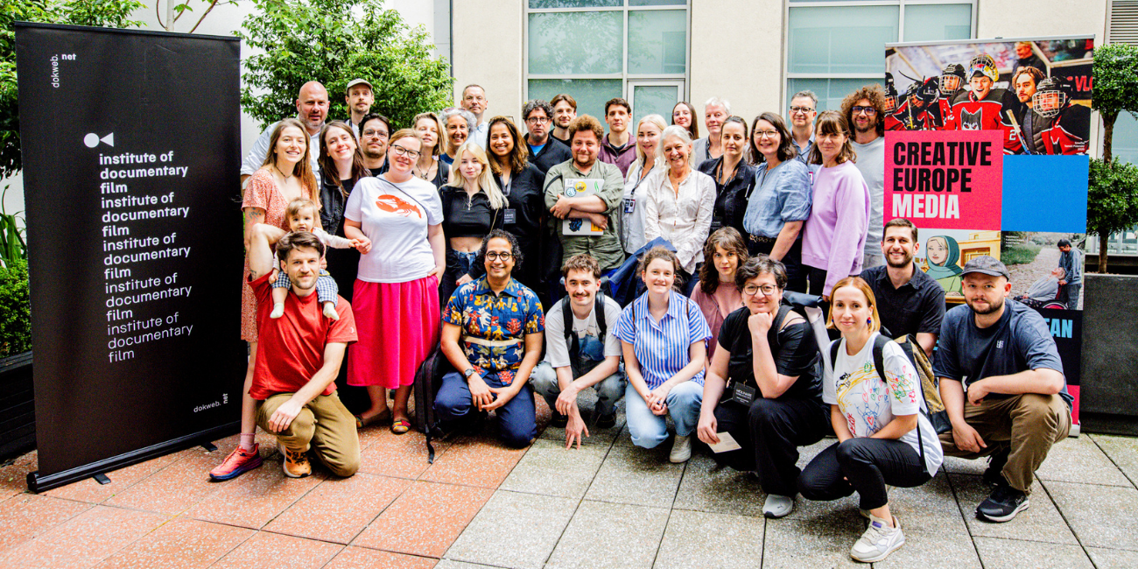
^{Photo: Kyle Patterson}

The tutors explored diverse aspects of documentary filmmaking. For example Marc Isaacs spoke on constructing unpredictable narrative structures, Diana El Jeiroudi dissected the delicate director-producer dynamic, Dominic Lees presented a case study on the use of Generative AI in documentary production, Khadidja Benouataf introduced the art of impact campaign producing and Olha Bregman and Christian Popp gave a case study on Cuba & Alaska, a standout project from East Doc Platform 2023 that had its world premiere at Sheffield DocFest. The festival also showcased other Ex Oriente Film alumni: Shards of Light by Mila Teshaieva & Marcus Lenz and December by Grzegorz Paprzycki, both of which had their world premieres there.

Participant Agata Jujeczka (House in a Bottle) reflected: “The Ex Oriente workshop cuts through the industry noise to ask the essential question: Why does this film need to exist? The opening conversation with our mentor Filip Remunda opened spaces for unlimited experimentation and authentic storytelling. Together with the director Ania Morawiec, we explored House in a Bottle not for its marketability but for its authenticity – including the newest challenges that GenAI brings.” She also gave a special shout-out to tutor Gianluca Mataresse for “bringing such infectious creative energy” to their sessions.

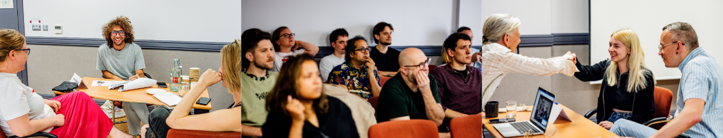
^{Photos: Kyle Patterson}

1st session of Ex Oriente Series at Sunny Side of the Doc
This year marked the third time our workshop for documentary series was organized in collaboration with one of the world's leading marketplaces dedicated to linear and non-linear documentary films. “Our partnership with IDF perfectly combines international market opportunities with training excellence at the heart of Europe. This first 2025 Ex Oriente Series session proved that when you bridge creative vision with commercial realities, Central and Eastern European voices and stories can truly compete globally,” commented Aurélie Reman, Managing Director of Sunny Side of the Doc.

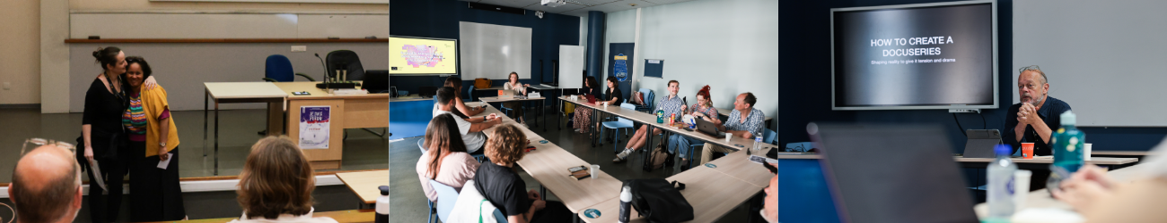
Photos: Tommy Delacuvellerie (Studio Pauleon)

Over three days, five selected documentary series teams underwent an intense development process through a combination of one-on-one consultations and collaborative group work focused on the unique demands of episodic storytelling. Under the guidance of lead tutor Ruth Reid, the programme was further enhanced by expert sessions from guest tutors. Chris Westendorp discussed episodic structure and character arcs, Samuel Joyce shared strategies for positioning docuseries in international markets and Lucio Mollica talked about the role of the showrunner, using Vietnam: The Birth of a Nation as a case study. Participants also gained insights from Mark Edwards, the former Director of Documentaries in Europe for Netflix.

Participant Andrius Lekavičius (Hijacked Life) commented on the tutor lineup: “Battle-tested producers, each carrying a different weapon. Mark with his forensic sense of narrative tension, Ruth giving examples from every docuseries ever made, and Chris, the gentle assassin who spots a potential character arc before you’ve even pitched the twist.” Gordon Lovitt (Justice as Legalised Terror) added: “I left the workshop with a myriad of things to explore to move the development of my series forward both creatively and production wise. A fun and really practical experience that will help bring my series to fruition.”

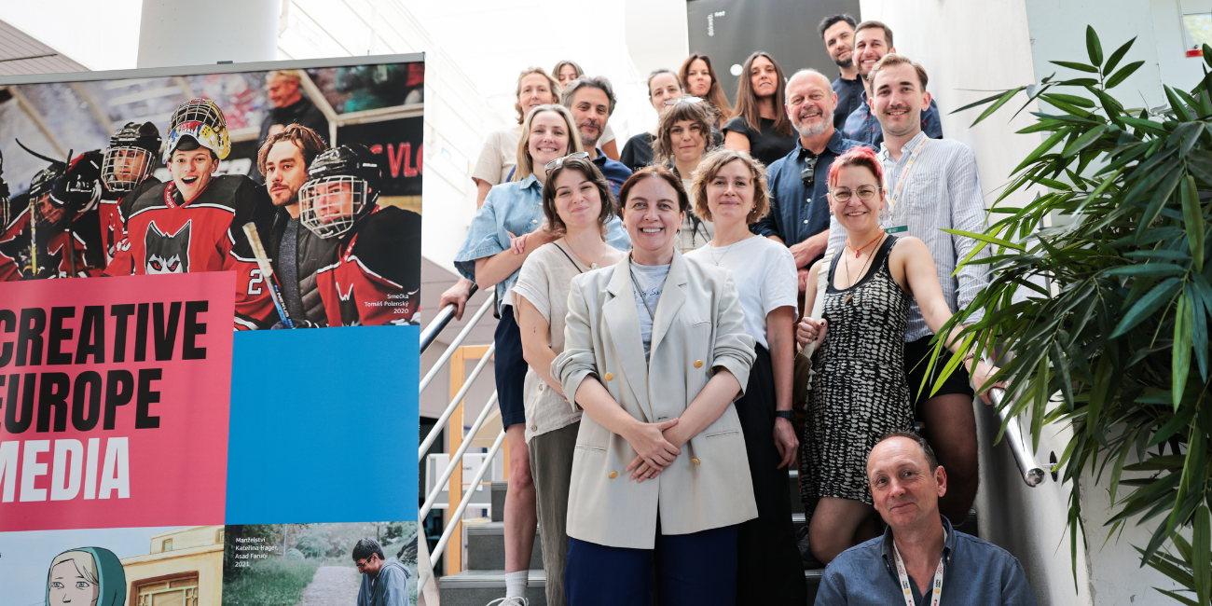
Photo: Tommy Delacuvellerie (Studio Pauleon)

What’s next?
The second sessions will take place this autumn. Ex Oriente Series is scheduled for September 21–23, in partnership with the International Serial Killer Festival of TV and Web Series in Brno, Czech Republic, while Ex Oriente Features will follow on October 19–23 at the Astra Film Festival in Sibiu, Romania.

For Ex Oriente Series, participants will be again guided by leading tutor Ruth Reid, a producer and consultant with over 20 years’ experience. including at HBO and Netflix, Mark Edwards, a 30-year industry veteran and former Director of Documentaries in Europe for Netflix, and Chris Westendorp, an award-winning Amsterdam-based screenwriter and documentary maker known for acclaimed TV series such as Penoza and Seven Little Criminals.

Ex Oriente Features tutors will include Niels Pagh Andersen, an award-winning editor of over 250 films including The Look of Silence, Emma Davie, documentary filmmaker and BAFTA-winning director who teaches at Edinburgh College of Art, Sean McAllister, known for his vérité documentaries like A Syrian Love Story and Salomé Jashi, a Georgian filmmaker awarded at multiple international festivals for The Dazzling Light of Sunset.

This edition is possible thanks to our donors: Creative Europe MEDIA, Ministry of Culture Czech Republic and the Czech Audiovisual Fund.

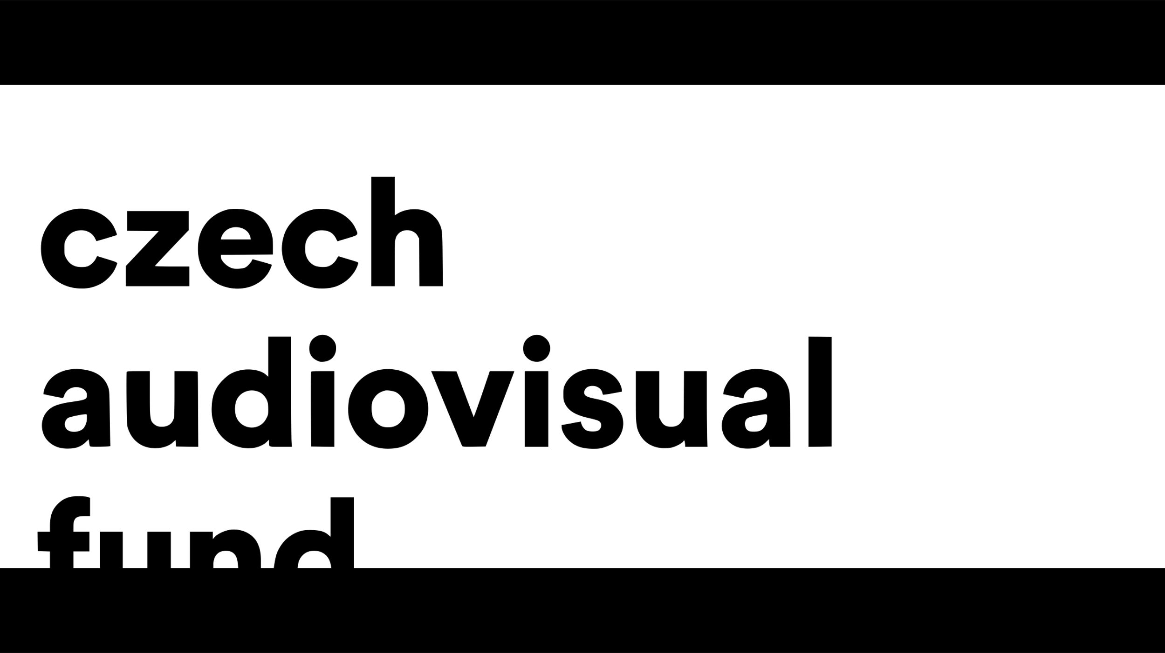

About the Institute of Documentary Film
Since 2001, the Institute of Documentary Film (IDF) has been supporting Eastern and Central European original documentary films in all stages of production. It assists emerging and experienced directors with the development of their films, and producers with the financing, distribution and promotion of their films, as well as with orientation on the international market. All this with the help of the vast experiences of renowned international experts. Films supported by IDF activities regularly win awards at leading film festivals. For the public, the IDF organises lectures and screenings of the most interesting documentaries not only in cinemas but also in various alternative spaces.
dokweb.net

Media contact:
Anna Jurková | PR IDF | tel.: +420 605 136 254 | e-mail: jurkova@dokweb.net

